# Gypsy Moth

Quercus, other hardwoods

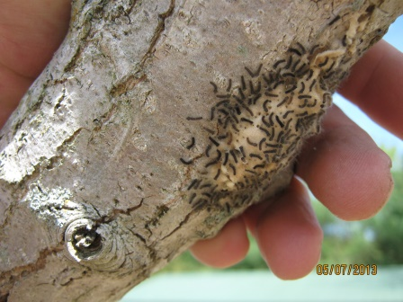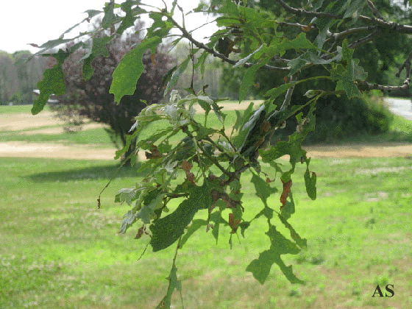

# Introduced Pine Sawfly

Pinus

>defoliation

# Winter moth

Quercus, Acer, Tilia, Ulmus, other hardwoods

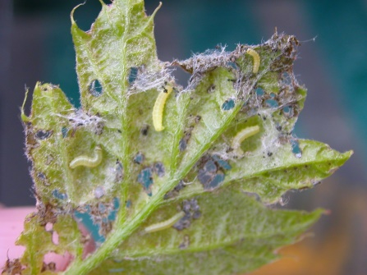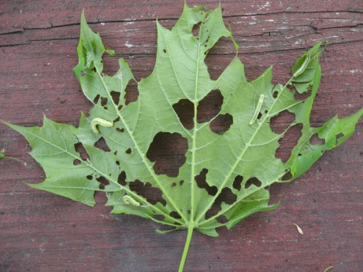

# Wooly Beech Scale

Fagus

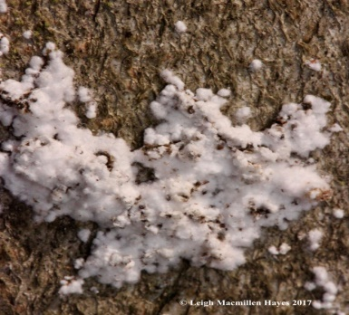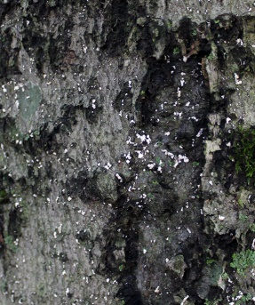

# Smaller European Elm Bark Beetle

Ulmus

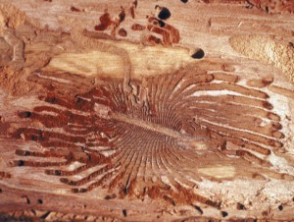

# Banded Elm Bark Beetle

Ulmus

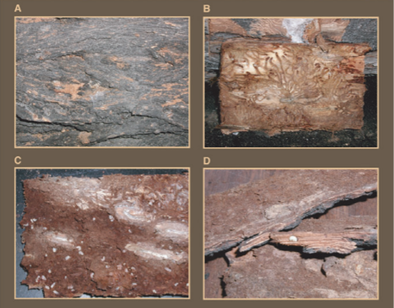

# Butternut Canker

JUCI

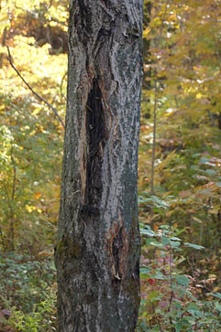

# Beech Bark Disease

FAGR

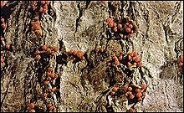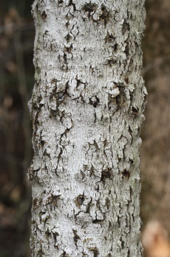

# Chestnut Blight

CADE

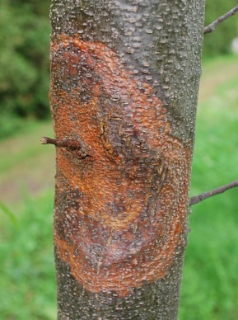

# Dutch Elm Disease

ULAM, ULRU, ULSP

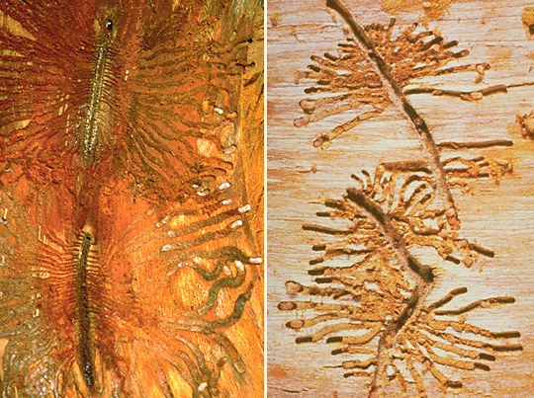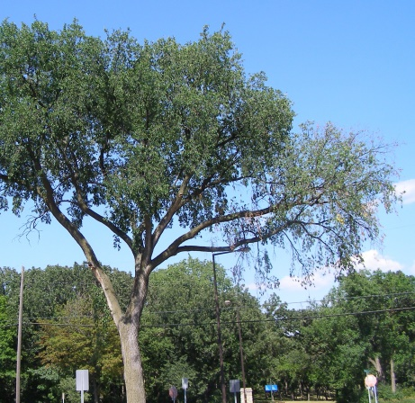

# White Pine Blister Rust

PIST

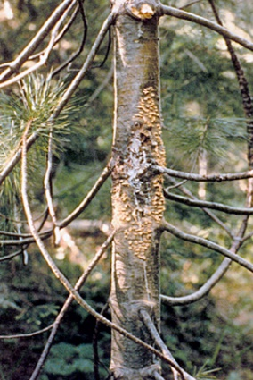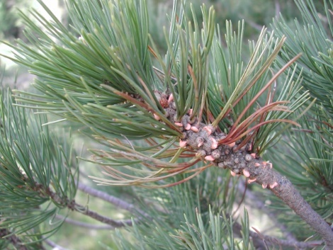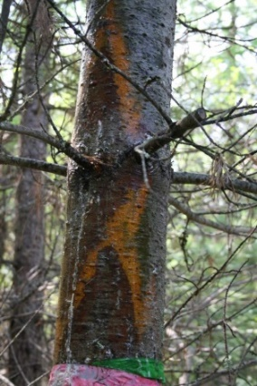

# Thousand Cankers Disease

JUCI/JUNI

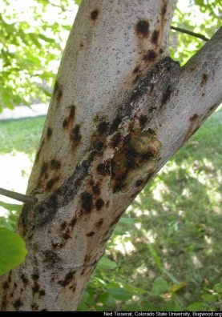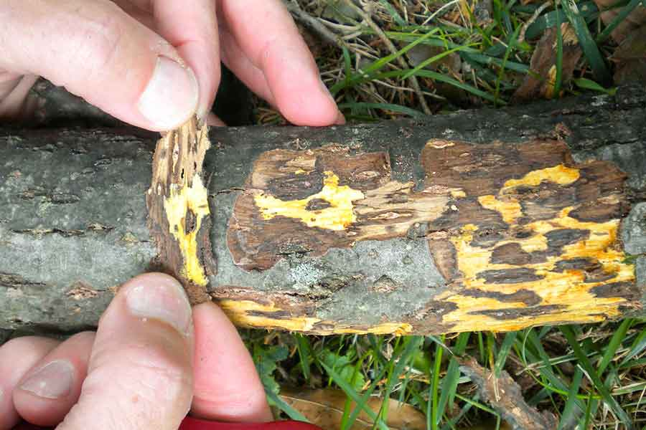

# CECA – Redbud / Cercis Canadensis

Dieback / Fungal disease Neofusicoccum spp.

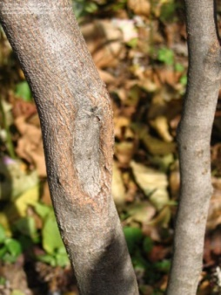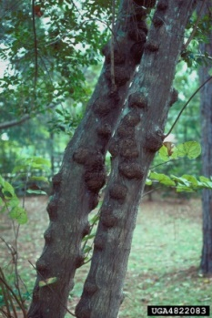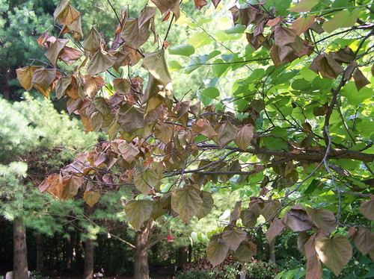

# Spotted Lanternfly

*Acer*, JUNI, FAGR, *Populus*

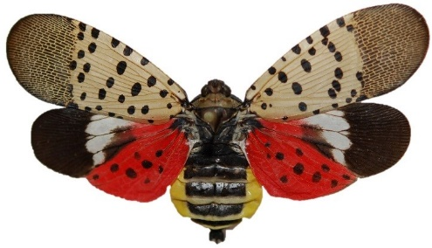

**Dogwood Anthracnose**

COFL

**LEAF SPOTS:** Leaf spots are round to blotchy and have tan centers with reddish purple margins.  During wet years, multiple spots on leaves coalesce to form irregular, tan blotches or blight entire leaves.

**SAPWOOD:** vascular cambium is chocolate brown as opposed to pale tan (healthy)

**DIEBACK:** Develops from lower branches up

**CANKER:** Dogwood anthracnose cankers girdle these twigs and shoots killing growth beyond that point.  Cankers develop at the point where infected *epicormic sprouts* attach to a branch or stem, which disrupt water and mineral transport beyond that point.

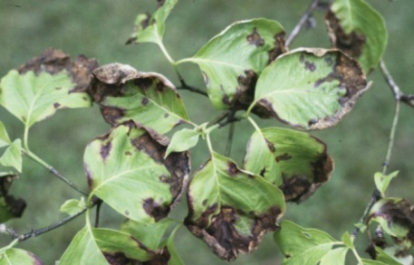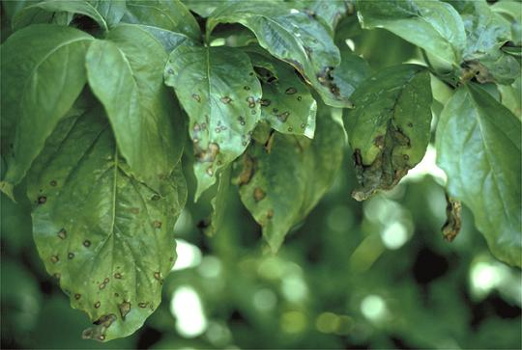

# EAB WATCH: Carya, Ulmus, Juglans

CACO, CAGL, CAOVL, CATO. ULAM, ULRU. JUCI, JUNI.